**Establish WRQ UCM**

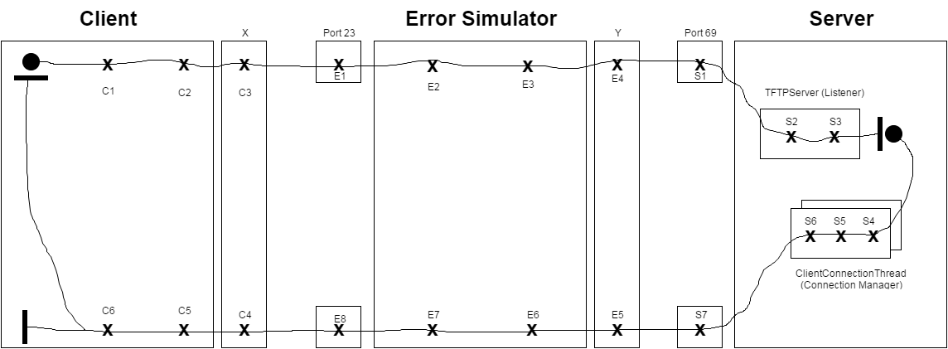

|  |  |  |
| --- | --- | --- |
| C1 – form DATA | E1 – receive datagram | S1 – receive datagram |
| C2 – create datagram | E2 – extract message | S2 – extract DATA |
| C3 – send datagram | E3 – create datagram | S3 – verify WRQ |
| C4 – receive datagram | E4 – send datagram | S4 – create socket |
| C5 – extract message | E5 – receive datagram | S5 – form ACK |
| C6 – verify ACK | E6 – extract message | S6 – create datagram |
|  | E7 – create datagram | S7 – send datagram |
|  | E8 – send datagram |  |

**File Transfer WRQ UCM**

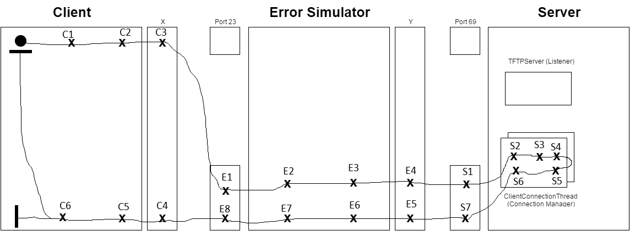

|  |  |  |
| --- | --- | --- |
| C1 – form DATA | E1 – receive datagram | S1 – receive datagram |
| C2 – create datagram | E2 – extract message | S2 – extract DATA |
| C3 – send datagram | E3 – create datagram | S3 – verify DATA |
| C4 – receive datagram | E4 – send datagram | S4 – Write File |
| C5 – extract message | E5 – receive datagram | S5 – form ACK |
| C6 – verify ACK | E6 – extract message | S6 – create datagram |
|  | E7 – create datagram | S7 – send datagram |
|  | E8 – send datagram |  |

**Establish RRQ UCM**

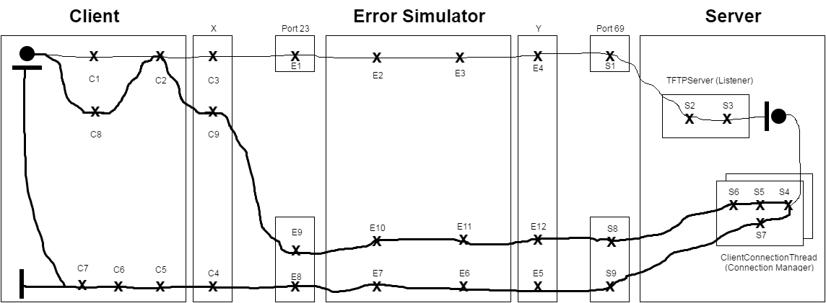

|  |  |  |
| --- | --- | --- |
| C1 – form message | E1 – receive datagram | S1 – receive datagram |
| C2 – create datagram | E2 – extract message | S2 – extract message |
| C3 – send datagram | E3 – create datagram | S3 – verify RRQ |
| C4 – receive datagram | E4 – send datagram | S4 – read DATA |
| C5 – extract DATA | E5 – receive datagram | S5 – verify ACK |
| C6 – verify DATA | E6 – extract message | S6 – extract message |
| C7 – write DATA | E7 – create datagram | S7 – create datagram |
| C8 – form ACK | E8 – send datagram | S8 – receive datagram |
| C9 – send datagram | E9 – receive datagram | S9 – send datagram |
|  | E10 – extract message |  |
|  | E11 – create datagram |  |
|  | E12 – send datagram |  |

**File Transfer RRQ UCM**

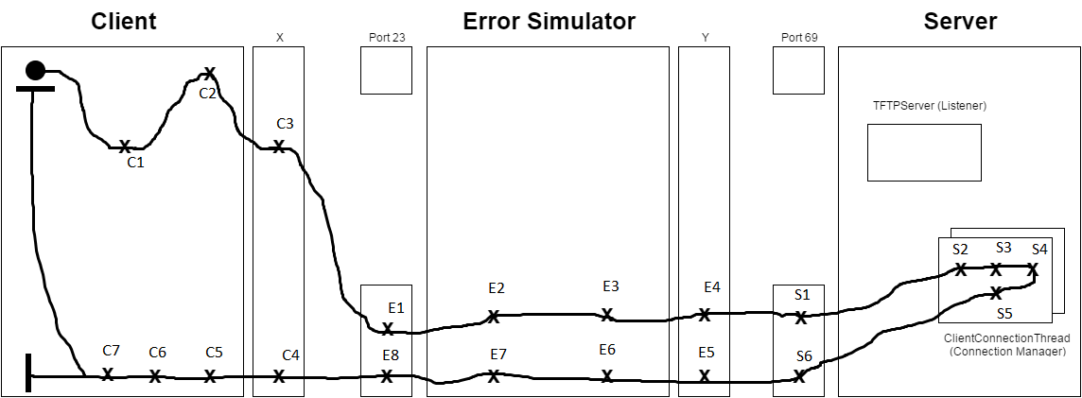

|  |  |  |
| --- | --- | --- |
| C1 – form message | E1 – receive datagram | S1 – receive datagram |
| C2 – create datagram | E2 – extract message | S2 – extract message |
| C3 – send datagram | E3 – create datagram | S3 – verify RRQ |
| C4 – receive datagram | E4 – send datagram | S4 – read DATA |
| C5 – extract DATA | E5 – receive datagram | S5 – form DATA |
| C6 – verify DATA | E6 – extract message | S6 – create datagram |
| C7 – Write DATA | E7 – create datagram |  |
|  | E8 – send datagram |  |